**Stock transaction program**

**Objective** To write a program that performs stock transaction calculations.

**Description**

Program takes inputs from user for purchasing shares – name, number of shares purchased, cost price per share, percentage of commission paid to broker – and evaluates the cost price of the stock and the commission paid to broker.

The program then takes inputs from user for selling shares– number of shares sold, selling price per share, percentage of commission paid to broker after selling – and evaluates the selling price of stock, the commission paid to broker and then evaluates if the user made a profit or a loss.

The program is designed to handle negative scenarios –

1. User enters a negative input
2. User enters string where number input is required

**Snapshots of Testcases:**

1. Given input – Stock transaction profit for Joe

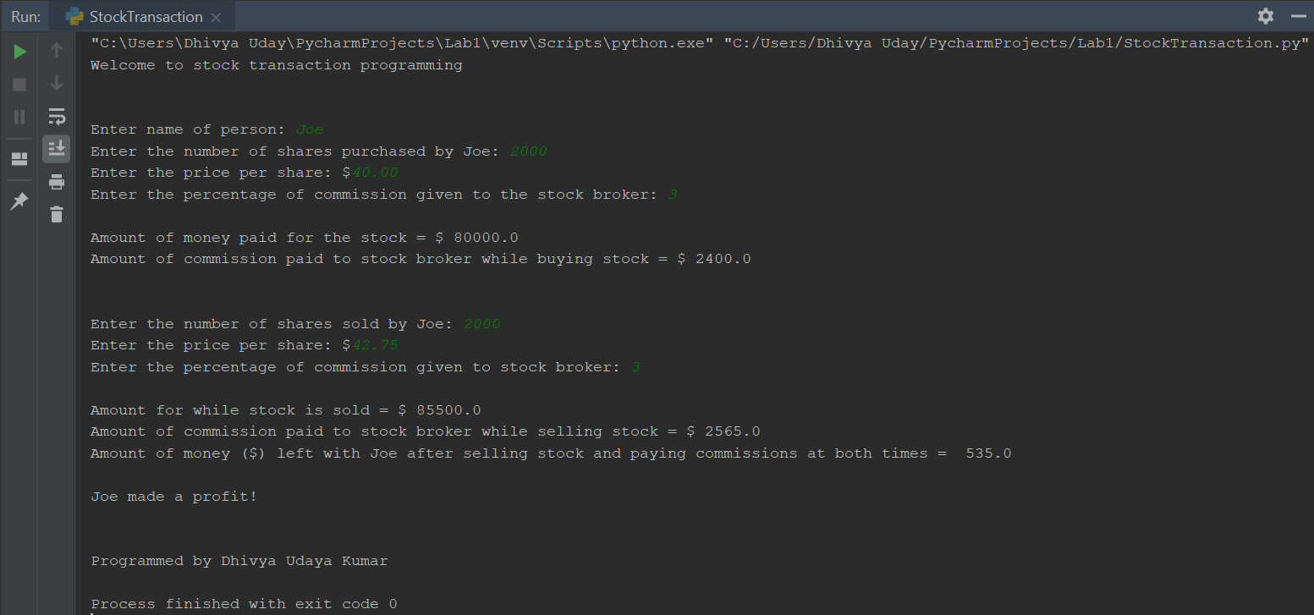

1. Custom input – Stock transaction loss for Bob

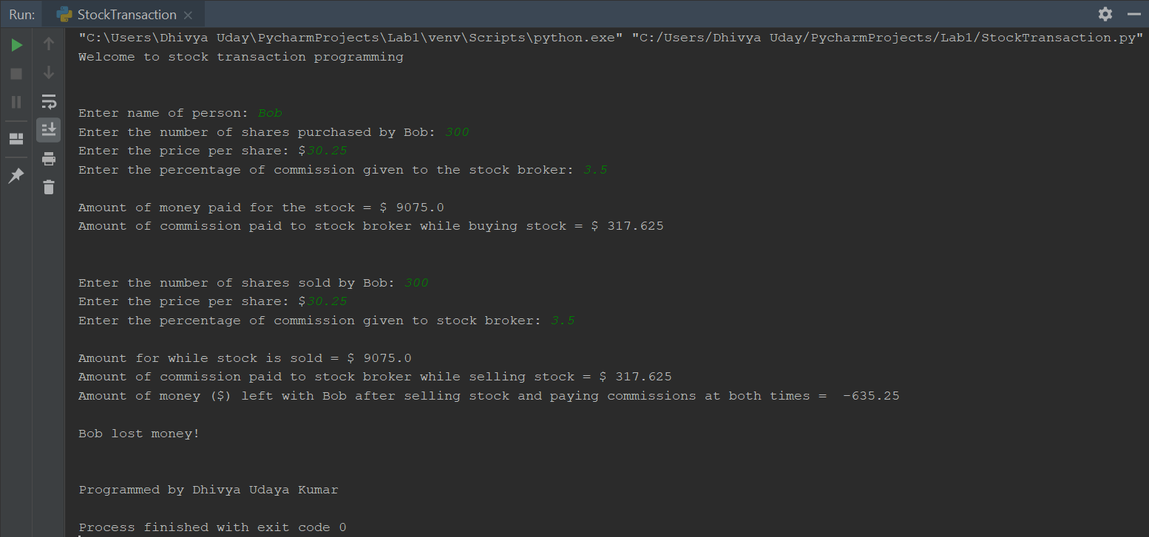

1. Negative scenario – Entering negative inputs

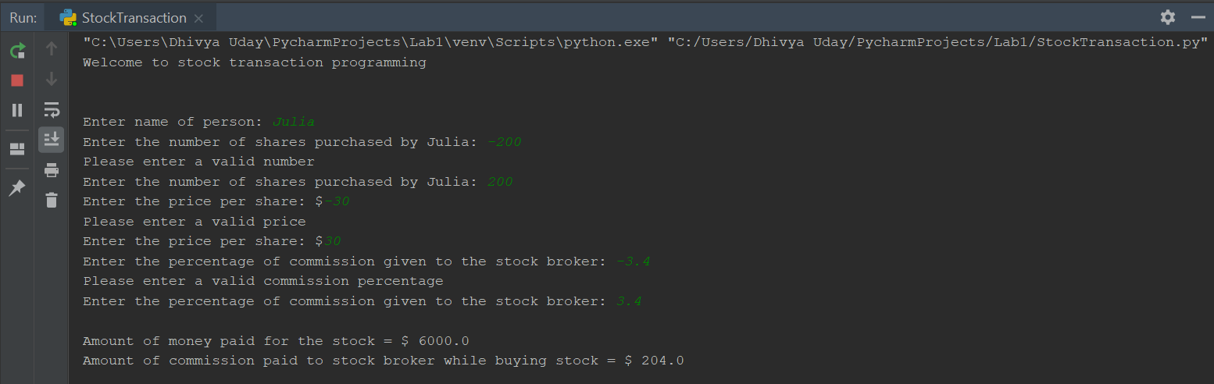

1. Negative scenario – Entering wrong input (ex. Accidentally entering string where number input is required)

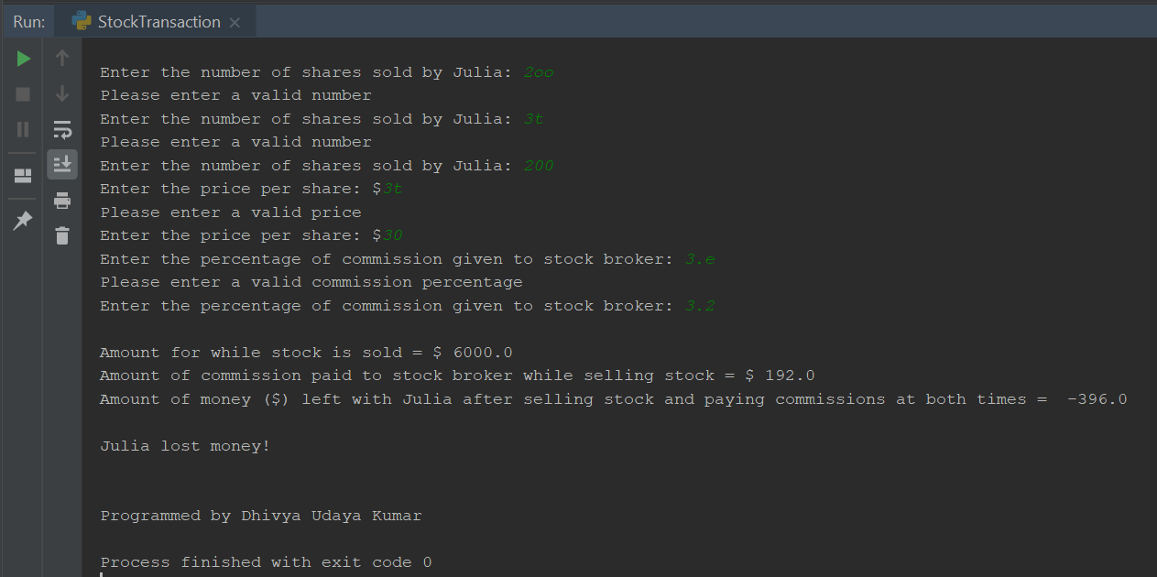

**Source code:**

#Program to perform stock transaction calculations  
#Programmed by Dhivya Udaya Kumar  
  
print("Welcome to stock transaction programming")  
print("\n")  
  
#Inputs for purchasing shares  
customerName = input("Enter name of person: ")  
  
while True:  
 try:  
 numOfSharesBought = int(input("Enter the number of shares purchased by " + customerName + ": "))  
 assert(numOfSharesBought > 0), 'Number must be greater than 0'  
 break  
 except:  
 print("Please enter a valid number")  
  
while True:  
 try:  
 pricePerShareBought = float(input("Enter the price per share: $"))  
 assert(pricePerShareBought > 0), 'Price must be greater than 0'  
 break  
 except:  
 print("Please enter a valid price")  
  
while True:  
 try:  
 commissionPercentageWhileBuying = float(input("Enter the percentage of commission given to the stock broker: "))  
 assert (commissionPercentageWhileBuying > 0), 'Commission percentage must be greater than 0'  
 break  
 except:  
 print("Please enter a valid commission percentage")  
  
print("")  
  
#Shares purchase calculations  
totalShareBuyingPrice = numOfSharesBought * pricePerShareBought  
print("Amount of money paid for the stock = $", totalShareBuyingPrice)  
totalCommissionWhileBuying = totalShareBuyingPrice * commissionPercentageWhileBuying / 100  
print("Amount of commission paid to stock broker while buying stock = $",totalCommissionWhileBuying)  
print("\n")  
  
#Inputs for selling shares  
while True:  
 try:  
 numOfSharesSold = int(input("Enter the number of shares sold by " + customerName + ": "))  
 assert (numOfSharesBought > 0), 'Number must be greater than 0'  
 break  
 except:  
 print("Please enter a valid number")  
  
while True:  
 try:  
 pricePerShareSold = float(input("Enter the price per share: $"))  
 assert (numOfSharesBought > 0), 'Price must be greater than 0'  
 break  
 except:  
 print("Please enter a valid price")  
  
while True:  
 try:  
 commissionPercentageWhileSelling = float(input("Enter the percentage of commission given to stock broker: "))  
 assert (numOfSharesBought > 0), 'Commission percentage must be greater than 0'  
 break  
 except:  
 print("Please enter a valid commission percentage")  
  
print("")  
  
#Shares selling calculations  
totalShareSellingPrice = numOfSharesSold * pricePerShareSold  
print("Amount for while stock is sold = $", totalShareSellingPrice)  
totalCommissionWhileSelling = totalShareSellingPrice * commissionPercentageWhileSelling / 100  
print("Amount of commission paid to stock broker while selling stock = $", totalCommissionWhileSelling)  
amountRemaining = (totalShareSellingPrice - totalCommissionWhileSelling) - (totalShareBuyingPrice + totalCommissionWhileBuying)  
print("Amount of money ($) left with " + customerName + " after selling stock and paying commissions at both times = ", amountRemaining)  
print("")  
  
if amountRemaining < 0:  
 print(customerName + " lost money!")  
elif amountRemaining == 0:  
 print(customerName + " neither made a profit nor loss!")  
else:  
 print(customerName + " made a profit!")  
  
print("\n")  
print("Programmed by Dhivya Udaya Kumar")